Name | SURENDER KUMAR |  |  |  |  | 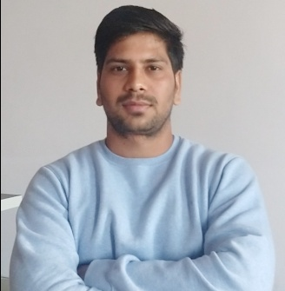
Designation | ASSISTANT PROFESSOR
Department | MATHEMATICS
Qualification | M.SC MATH (2018)
Research | NIL
Experience (in years) | Total  NIL |  |  | Teaching  NIL |  | Research  NIL
Contact Details: | E-mail  syadav2283@gmail.com |  |  |  | Mobile/Phone  8683011814
Books/Chapters Published | NIL
Research Publications | International Journals |  | National Journals |  | International Conferences |  | National Conferences
 | NIL |  | NIL |  | NIL |  | NIL
Research Guidance |  | Ph.D. |  |  | Masters |  | NIL
Research Projects |  | Completed |  |  | Inprogress |  | NIL
Consultancy Projects |  | Completed |  |  | Inprogress |  | NIL
Seminar/Conference/STTPs |  | Attended |  |  | Organized |  | NIL
Professional Affiliations |  | KURUKSHETRA UNIVERSITY KURUKSHETRA
Awards/ Fellowships etc. |  | NET (JRF)

