Name | Dr. Parveen Kumar Gaur |  |  |  |  | 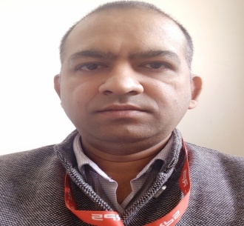
Designation | Assistant Professor(Mathematics)
Department | Mathematics
Qualification | M.Sc.(Math)(2004), M. Phil (math)(2007), Ph.D( Jan.2015), PGDCA(2005)
Research | Mathematical Modeling of Sinter Metal forming
Experience (in years) | Total  15 Years |  |  | Teaching  15 Years |  | Research
Contact Details: | E-mail  parvennegaur1980@gmail.com |  |  |  | Mobile/Phone  9416526411
Books/Chapters Published | Three
Research Publications | International Journals |  | National Journals |  | International Conferences |  | National Conferences
 | 10 |  | 02 |  | 01 |  | 05
Research Guidance |  | Ph.D. |  | 03 | Masters |  | NIL
Research Projects |  | Completed |  | - | Inprogress |  | NIL
Consultancy Projects |  | Completed |  | - | Inprogress |  | NIL
Seminar/Conference/STTPs |  | Attended |  | 17 | Organized |  | 03
Professional Affiliations |  | DCRUST Murthal, ALGAPPA UNI.,KUK, GJU Hisar
Awards/ Fellowships etc. |  | -

