Name | Mr. Anil Kumar |  |  |  |  | 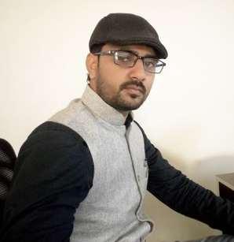
Designation | Assistant Professor
Department | Geography
Qualification | M. Sc. (Geography, 2012)  Kurukshetra University, Hisar
Research | NIL
Experience (in years) | Total  6 Y, 10 M |  |  | Teaching  6 Y, 10 M |  | Research  NIL
Contact Details: | E-mail  yoursanilrao7@gmail.com |  |  |  | Mobile/Phone  +91-8059681841
Books/Chapters Published | NIL
Research Publications | International Journals |  | National Journals |  | International Conferences |  | National Conferences
 | NIL |  | NIL |  | NIL |  | 01
Research Guidance |  | Ph.D. |  | NIL | Masters |  | NIL
Research Projects |  | Completed |  | NIL | Inprogress |  | NIL
Consultancy Projects |  | Completed |  | NIL | Inprogress |  | NIL
Seminar/Conference/STTPs |  | Attended |  | 01 | Organized |  | 01
Professional Affiliations |  | Kurukshetra University, Hisar
Awards/ Fellowships etc. |  | UGC NET

