International School, Rewari
Class III
October Work Planner
Session : 2019 – 20
Dear students
A warm welcome back to another action-packed term with full enthusiasm indicating another incredible and productive school year. Rpsians are indeed a joyous and caring community with the common goals of nurturing responsible students and promoting high-level learning. Let us begin this 2nd term with joyful activities, new concepts and pleasant weather and many holidays lining up the calendar, the reason being the month has many festivals.
ENGLISH  - Chapter 6  - Chapter 4 Small Book Reading  - Application writing  Grammar  - Chapter 12 to 15, 19, 20  MATHS  - Chapter 8: Division  - Chapter 13 : Pictograph  EVS  - Chapter 7, 8, 9 | HINDI  गुंजन  - पाठ – 9 (शून्य)  - पाठ – 8 (अनोखी चिड़िया )  व्याकरण  - पाठ – 7 (सर्वनाम)  - पाठ – 8 (विशेषण)  - गिनती  Reasoning  - Chapter -5,6  ART  - Page no. 21 to 30 | DANCE  - Folk Dance  MUSIC  - Gandhi Bhajan (Raghupati raghav raja raam)  SPORTS  - Kho- Kho and Skating  YOGA  - Laughing Yoga  - Meditation
GK  September and October month magazine quiz and 3 assignments | Japanese  - Japanese Verb | COMPUTER  - Chapter 6

Activities and Competitions of the month:-  - Gandhi Jayanti  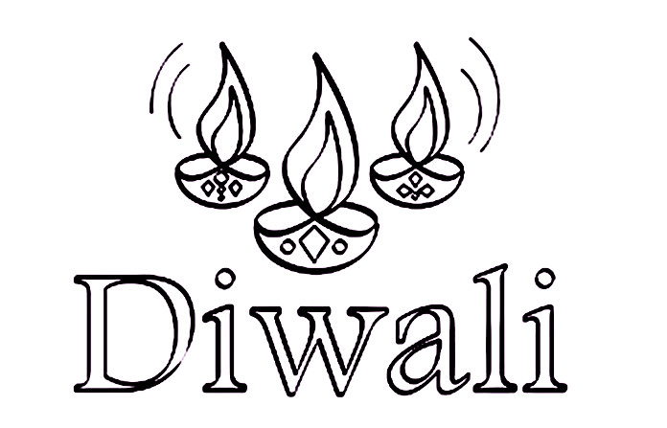  - Navratri  - Dusshera  - Diwali  - World Food Day | Holidays of the month:-  - Dusshera (8th October 2019)  - 2nd Saturday (12th October 2019)  - Karwa Chauth (17th October 2019)  - Diwali break (25th October to 29th October 2019)

PTM of the month:- 6th October 2019 (Sunday)

Class Teacher’s Signature Coordinator’s Signature Principal’s Signature

Note:- Work planner may subject to minor changes.

Activities and Competitions of the month:-

- Gandhi Jayanti
- Navratri
- Dusshera
- Diwali
- World Post Office Day
- World Food Day

Holidays of the month:-

- Dusshera (8th October 2019)
- 2nd Saturday (12th October 2019)
- Karwa Chauth (17th October 2019)
- Diwali break (25th October to 29th October 2019)

PTM of the month:- 6th October 2019 (Sunday)

